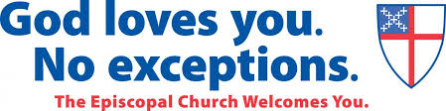

As Episcopalians, we are followers of Jesus Christ, our Lord, and we believe in the Father, Son, and Holy Spirit.

The Episcopal Church has members in the United States and the territory of Puerto Rico; and also in Colombia, the Dominican Republic, Ecuador, Venezuela, Curacao, Austria, Belgium, France, Germany, Italy, Switzerland, Haiti, Honduras, Micronesia, Taiwan, and the Virgin Islands.

We strive to love our neighbors as ourselves and respect the dignity of every person.

The Episcopal Church is part of the worldwide Anglican Communion, and traces its heritage to the beginnings of Christianity.

Our liturgy retains ancient structure and traditions and is celebrated in many languages.

Both men and women, including those who are married, are eligible for ordination as deacons, priests and bishops.

We believe in amendment of life, the forgiveness of sin, and life everlasting.

Lay people exercise a vital role in the governance and ministry of our church.

Holy Communion may be received by all baptized Christians, not only members of the Episcopal Church.

We uphold the Bible and worship with the Book of Common Prayer.

We affirm that committed relationships are lifelong and monogamous. Episcopalians also recognize that there is grace after divorce and do not deny the sacraments to those who have been divorced.

We affirm that issues such as birth control are matters of personal informed conscience.

We celebrate our unity in Christ while honoring our differences, always putting the work of love before uniformity of opinion.

All are welcome to find a spiritual home in the Episcopal Church.

